**internship Week 1 Report:**

**Project Initiation and Understanding**

**Exploring the Landscape of Sports Video Analysis Applications and Techniques for ML/AI Model Development**

**Project Overview:**

The project involves the development of a Video Analysis Application to aid in sports strategy planning. The primary goal is to create an ML/AI model capable of identifying specific scenarios in sports videos, such as 'Goal moments,' 'Happy moments,' and 'Loss moments,' and analyzing emotions expressed in the video frames.

**1. Scope and Goals Clarification:**

The project scope has been defined with a primary focus on the development of a specialized video analysis application tailored for football coaching. This comprehensive scope encompasses various key components, including video input processing, object detection for identifying players and goals, emotion analysis for capturing player and crowd emotions during specific scenarios, event detection algorithms to recognize critical occurrences such as goals and celebrations, temporal analysis for understanding the timing and sequence of events, segmentation to extract relevant video clips of 'Goal moments,' 'Happy moments,' and 'Loss moments,' user customization features for flexibility in event tagging, and the optional integration of wearable technology to capture additional player-specific metrics. This scope ensures a holistic approach to football match analysis, empowering coaches with detailed insights for strategic planning and performance improvement.

The project goals align with the identified requirements and objectives, focusing on the delivery of a powerful and user-friendly video analysis application. These goals include enabling football coaches to strategically plan for upcoming matches by extracting insights from video analysis, facilitating in-depth opponent team analysis, concentrating on key scenarios like goal moments, happy moments, and loss moments.

**2. Review Existing Video Analysis Applications and Techniques:**

**Application Exploration:**

Conducted a comprehensive review of notable sports video analysis applications, such as Sports Insights, Hudl Sportscode, and Catapult AMS. Explored their features and functionalities, emphasizing object detection, emotion analysis, and event detection.

**Identified Trends:**

1. Object Detection:

* Player tracking is a common feature, with some applications using advanced algorithms for real-time movement analysis.

2. Emotion Analysis:

* Emotion analysis primarily focuses on crowd reactions, with limited attention to player emotions.

3. Event Detection:

* Events often revolve around critical plays, such as goals and assists, with manual tagging options for user customization.

**3. Architecture Definition:**

**High-Level Architecture:**

1. **Input Module:**
   * Handles video input from football matches.
   * May involve video streaming or loading from a file.
   * Output: Raw video frames.
2. **Object Detection Module:**
   * Utilizes a pre-trained object detection model to identify key elements (players, goals).
   * Extracts bounding boxes and object labels.
   * Output: Detected objects and their locations.
3. **Emotion Analysis Module:**
   * Implements facial emotion recognition on regions of interest (ROIs) from detected faces.
   * Analyzes facial expressions in the context of detected objects.
   * Output: Emotions associated with players and crowd.
4. **Event Detection Module:**
   * Incorporates algorithms to detect specific events (goals, celebrations, setbacks).
   * Analyzes the combination of detected objects and emotions.
   * Output: Identified events and their timestamps**.**
5. **Temporal Analysis Module:**
   * Integrates results from object detection, emotion analysis, and event detection.
   * Analyzes the temporal relationships between events, objects, and emotions.
   * Output: Temporal context and patterns.
6. **Scenario Analysis Module (Machine Learning Model):**
   * Applies machine learning models for recognizing specific patterns associated with different scenarios.
   * Uses features derived from the results of temporal analysis.
   * Trained on a labelled dataset indicating scenarios at various temporal points.
   * Output: Predicted scenarios and confidence scores.
7. **Output Module:**
   * Generates segmented videos highlighting 'Goal moments,' 'Happy moments,' and 'Loss moments' based on the identified scenarios.
   * Provides a user-friendly interface for visualization and navigation.
   * Output: Segmented and annotated video clips.

**Data Flow:**

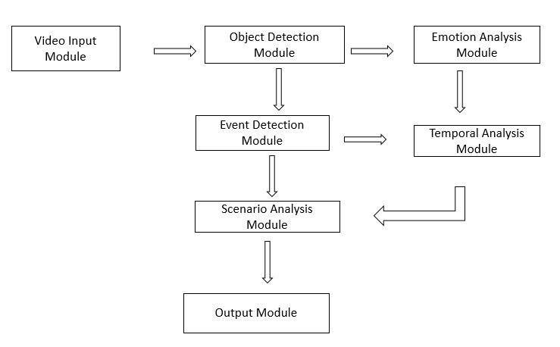

* **Video Input → Object Detection:**
  + Raw video frames are processed by the Object Detection Module, identifying players and goals.
* **Object Detection → Emotion Analysis:**
  + ROIs based on detected faces are passed to the Emotion Analysis Module for facial emotion recognition.
* **Object Detection, Emotion Analysis → Event Detection:**
  + Detected objects and emotions are combined in the Event Detection Module to identify specific events.
* **Object Detection, Emotion Analysis, Event Detection → Temporal Analysis:**
  + Results from the previous modules are integrated in the Temporal Analysis Module for understanding temporal context.
* **Temporal Analysis → Scenario Analysis (Machine Learning Model):**
* Temporal patterns are used as features for the Scenario Analysis Module, a machine learning model trained to recognize scenarios.
* **Scenario Analysis → Output Module:**
  + Identified scenarios are used by the Output Module to generate segmented videos, providing a visual representation of 'Goal moments,' 'Happy moments,' and 'Loss moments.'

**Technologies Considered:**

1. **Input Module:**
   * Technology: Utilizing OpenCV in Python for handling video input.
2. **Object Detection Module:**
   * Technologies:
     + TensorFlow
     + YOLO (You Only Look Once)
     + SSD (Single Shot Multibox Detector)
     + Faster R-CNN
3. **Emotion Analysis Module:**
   * Technologies:
     + TensorFlow
     + Pre-trained facial emotion recognition models like AffectNet
4. **Event Detection Module:**
   * Technologies:
     + Custom algorithms based on patterns and features
     + scikit-learn
     + NumPy and SciPy
5. **Temporal Analysis Module:**
   * Technologies:
     + Integration using Python and relevant libraries
     + Visualization with Matplotlib or Seaborn
     + Data manipulation with NumPy and Pandas
6. **Scenario Analysis Module (LSTM - Long Short-Term Memory):**
   * Technology: Leveraging LSTM for recognizing temporal patterns associated with different scenarios.

**Next Steps:**

* **1. Refined Design Document:** Refine and expand the design document, incorporating innovative technological considerations.
* **2. Prototype Development Kickoff:** Begin the development of a prototype with a focus on unique features and user-centric design.
* **3. Detailed Technology Selection**: Finalize the technology stack based on considerations of innovation, scalability, and ease of integration.
* **4. Communication Protocol Research:** Explore optimal communication protocols between frontend and backend, with an emphasis on real-time capabilities.

**Conclusion:**

The first week has laid the groundwork for an exciting journey. I am enthusiastic about exploring innovative solutions and contributing to a project that seamlessly integrates technology and sports strategy.